MOBILE LEVEL MANAGER
GUIDELINE

1. How to change GUISkin and images?
- Click on Level Manager prefab, see on Inspector window.
- If you want to change images, see this image to know images for each function:

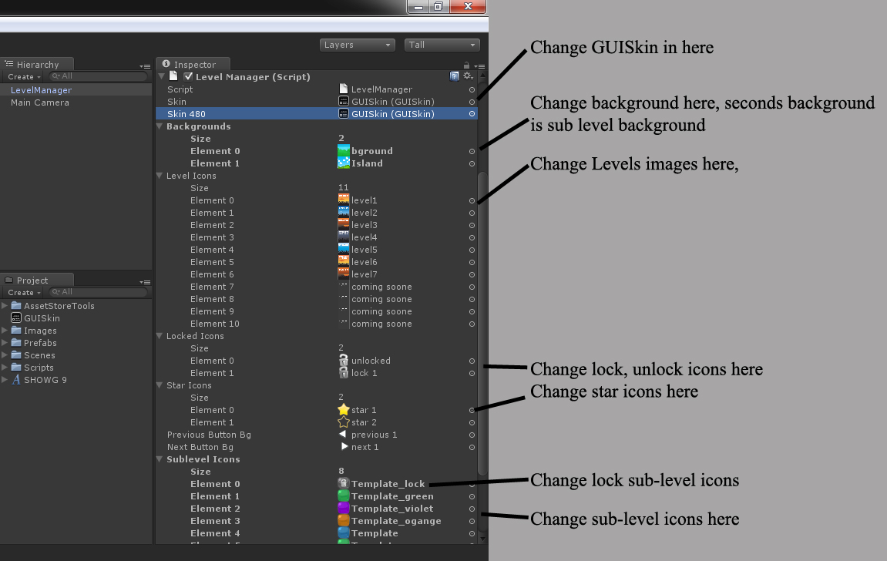

2. How to add more Level, sub level?
Open file Scripts/LevelManager.cs. Find 2 variables "subLevelsUnlocked" and "maxSubLevels". You will see:
public static int[] subLevelsUnlocked = new int[]{1,0,0,0,0,0,0,0,0,0};
public static int[] maxSubLevels = new int[]{10,12,14,15,16,18,15,0,0,0};
-subLevelsUnlocked: array number of unlocked sub levels.
-maxSubLevels: array number of sub levels, value 0 mean that level is empty and you cannot open it.
- If you want have 5 levels, and each level has 20 sub levels, you can change like this:
public static int[] subLevelsUnlocked = new int[]{1,0,0,0,0};
public static int[] maxSubLevels = new int[]{20,20,20,20,20};
And then, you change size of Level icons and Sublevel Icons to 5 on Inspector like above image.

-If you want have 6 levels, include 1 empty level, you can change like this:
//add one more element to arrays
public static int[] subLevelsUnlocked = new int[]{1,0,0,0,0,0};
public static int[] maxSubLevels = new int[]{20,20,20,20,20,0}; //0 mean level empty
And then, you change size of Level icons and Sublevel icons to 6 on Inspector like above image, and the last image should be a locked-transparent image.

